**VEHICLE MANAGEMENT SYSTEM USING SALESFORCE**

**1.INTRODUCTION**

Vehicle Management is an application where a customer Details are stored in order to choose cars,bikes and commercial vehicles for travel with in the city.The data which is stored here is further used to remind them if any offers are provided during the seasons and any updates regarding vehicles are sent to them in the form of messages and mails

* 1. **OVER VIEW**
* **A brief description about vehicle management**
  1. **PURPOSE**

* The use of the project.
* All light duty vehicles
* School buses
* Private vehicles
* Leased vehicles

**2.PROBLEM DEFINITION & DESIGN THINKING**

**2.1 Empathy Map**

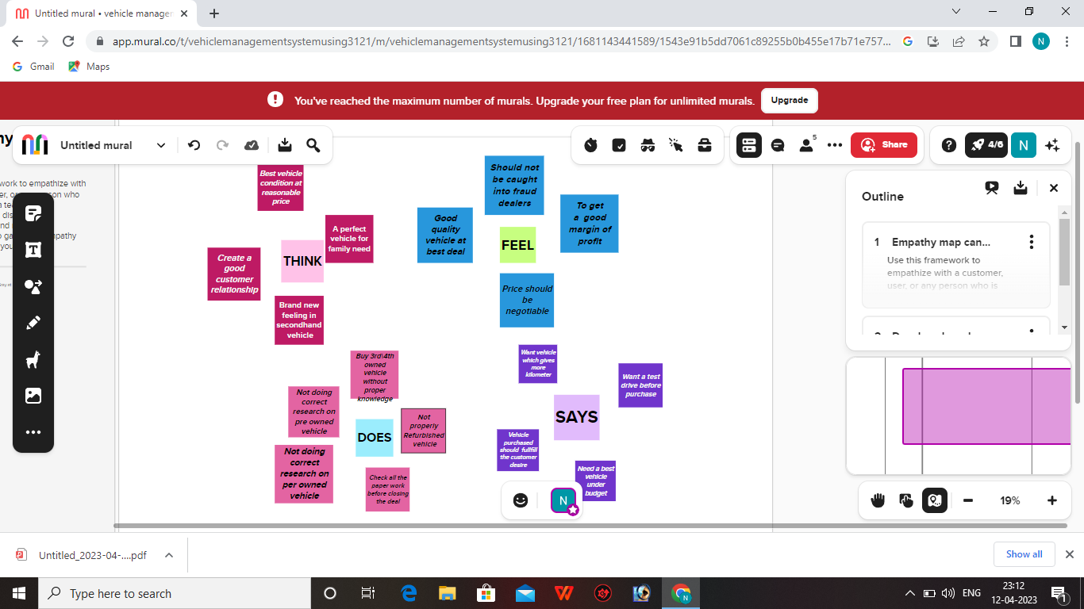

**2.2 Ideation & Brainstorming Map**

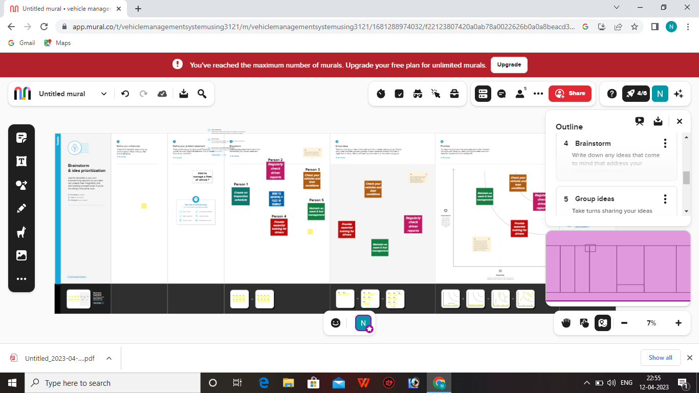

**3.RESULT**

**3.1 Data Model**

|  |  |  |
| --- | --- | --- |
| **OBJECT NAME** | **FIELDS IN THE OBJECT** | |
| **VEHICLES** | **FIELD NAME** | **DATA TYPES** |
| **Customer name** | **Text** |
| **Customer mobile no** | **Number** |
| **Vehicle type**  **1. 2wheeler**  **2. 4 wheeler** | **Picklist** |
| **2WHEELER**   1. **HERO** 2. **HONDA** 3. **BAJAJ** 4. **ROYAL ENFIELD** 5. **TVS** 6. **KINETIC** 7. **OLA** 8. **JAWA** 9. **SD** 10. **BATTERY** | **Picklist** |
| **4WHEELER**   1. **RENAULT** 2. **SKODA** 3. **HONDA** 4. **HYUNDAI** 5. **SUZKI** 6. **MAHINDRA** 7. **VOLKSWAGEN** 8. **BENZ** 9. **AUDI** 10. **VOLVO** | **Picklist** |
| **Vehicle name** | **Text** |
| **Vehicle no** | **Text** |
| **Chassic no** | **Text** |
| **Colour** | **Text** |
| **Body type** | **Text** |
| **Vehicle includes**  **1.Fire extenuation**  **2.First aid kit**  **3.Multi charger kit**  **4.Stepney**  **5.Setreo**  **6.Tool kit**  **7.Tracking device**  **8.Tyre jack** | **Multi picklist** |
| **Condition**   1. **Good** 2. **Medium** 3. **Least** | **Picklist** |
| **Mileage** | **Text** |
| **Seats** | **Number** |
| **Start date** | **Date /Time** |
| **End date** | **Date/Time** |
| **Opportunity** | **Lookup** |
| **DRIVERS** | **FIELD LABEL** | **DATA TYPE** |
| **Driver name** | **Text** |
| **License no** | **Text** |
| **Mobile no** | **Number** |
| **Fire per hour** | **Text** |
| **Vehicle** | **lookup** |

**3.2Activity &Screenshot**

**Milestone 1:Creation Salesforce Org**

Activity 1:

Creating Developer Account Creating a developer org in salesforce.

1. Go to developers.salesforce.com/

2. Click on sign up.

3. On the sign up form, enter the following details :

a. First name & Last name

a. Email

b. Role : Developer

c. Company : College Name

d. County : India

e. Postal Code : pin code

f. Username : should be a combination of your name and company This need not be an actual email id, you can give anything in the format :

username@organization.com

**Login To Your Salesforce Account**

1.Go to salesforce.com and click on login.

2.Enter the username and password that you just created.

3.After login this is the home page which you will see.

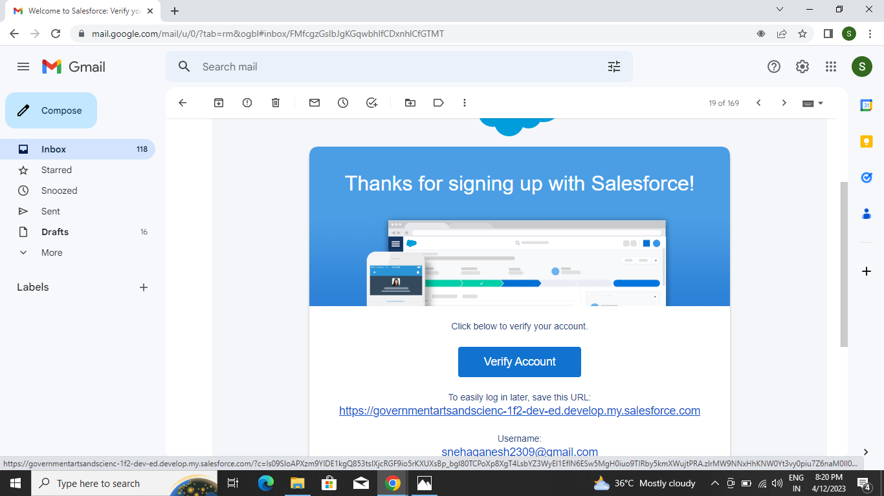

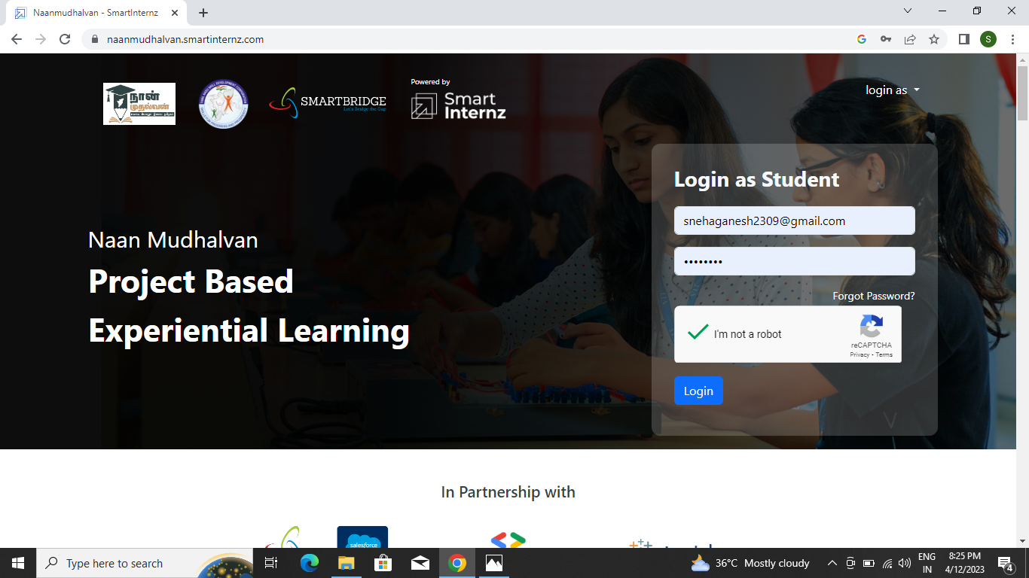

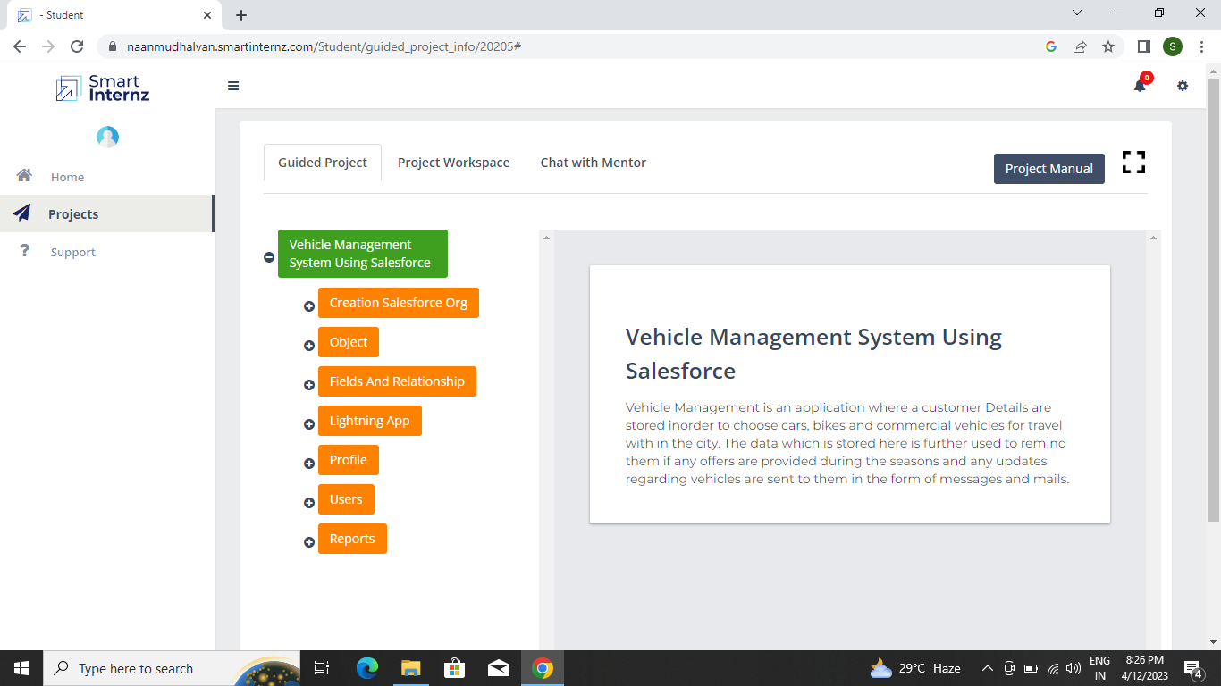

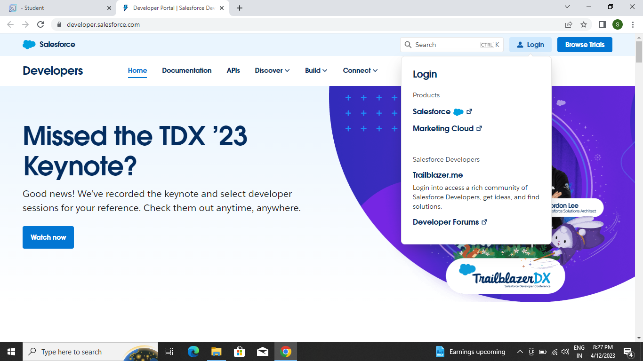

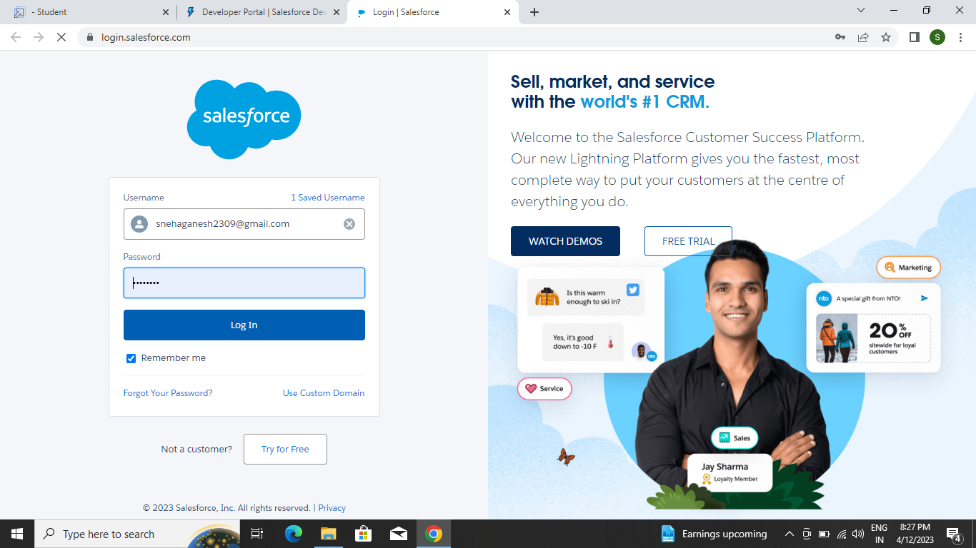

**Milestone-2:Object**

Salesforce objects are database tables that permit you to store data that is specific to an organisation. Salesforce objects are of two types: Standard Objects: Standard objects are the kind of objects that are provided by salesforce.com such as users, contracts, reports, dashboards, etc.

Standard Objects:Account,Contact,Opportunity.

Custom objects:Vehicles,Drivers.

**Activity 1:**

**To Create an object:**

Creation of Objects for Vehicle Management, For this Vehicle Management we need to create 2 objects i.eVehicles,Driver. The below steps will assist you in creating those objects.

● Click on the gear icon and then select Setup.

● Click on the object manager tab just beside the home tab.

● After the above steps, have a look on the extreme right you will find a Create Dropdown click on that and select Custom Object.

● Creation of Vehicle Object

**On the Custom Object Definition page, create the object as follows:**

● Label: Vehicle

● Plural Label: Vehicles

● Record Name: Vehicle Name

● Check the Allow Reports checkbox

● Check the Allow Search checkbox

● Click Save.

● Now create a custom tab. Click the Home tab, enter Tabs in Quick Find and select Tabs.

● Under Custom Object Tabs, click New.

● For Object, select Vehicle.

● For Tab Style, select any icon.

● Leave all defaults as is. Click Next, Next, and Save.

**Activity 2:**

To Create a driver object continue the same steps Which is followed for the above object.

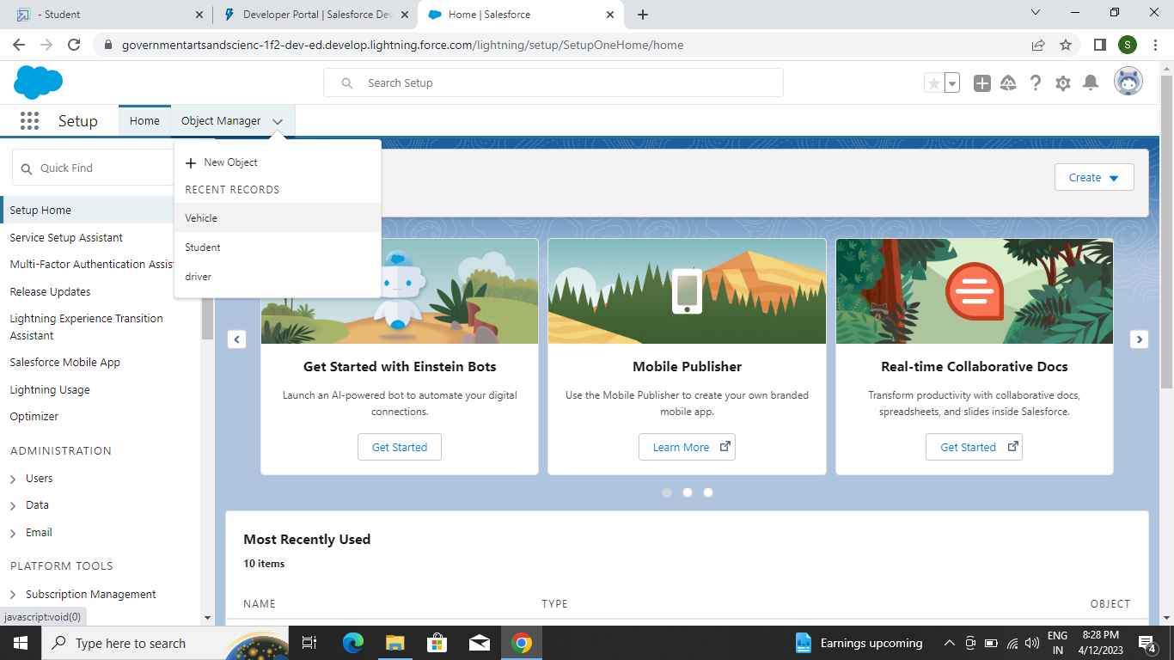

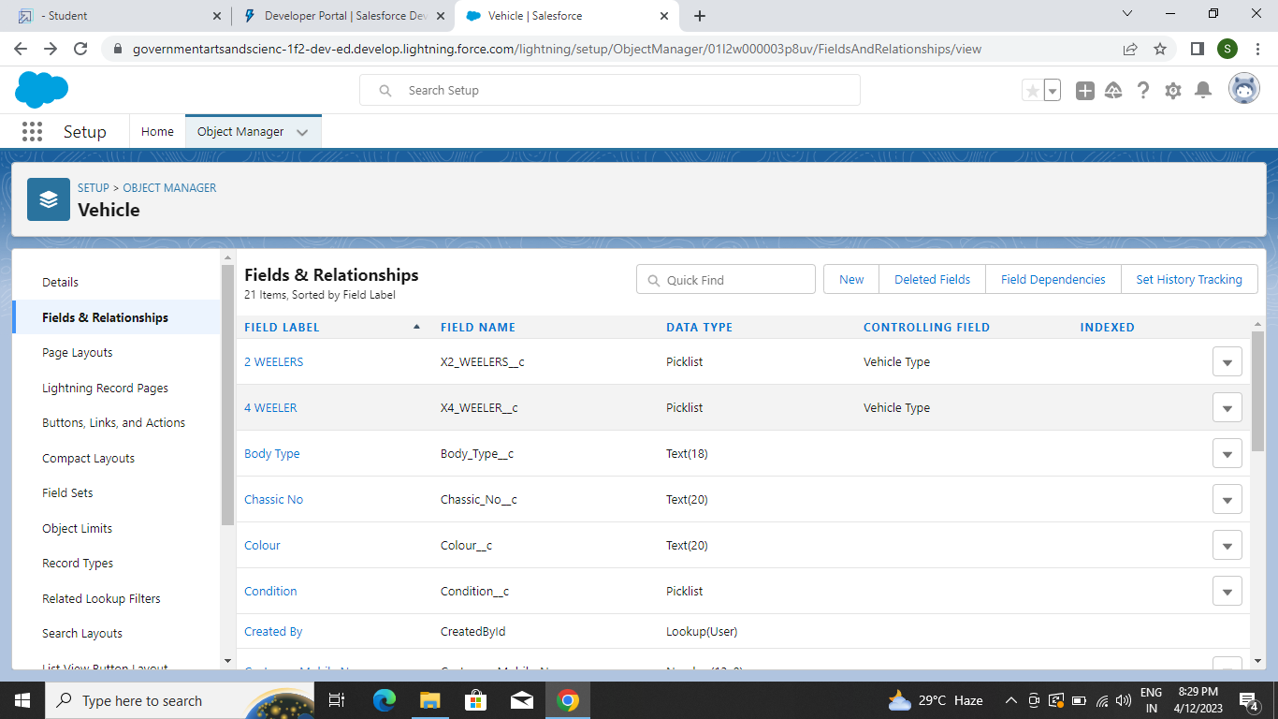

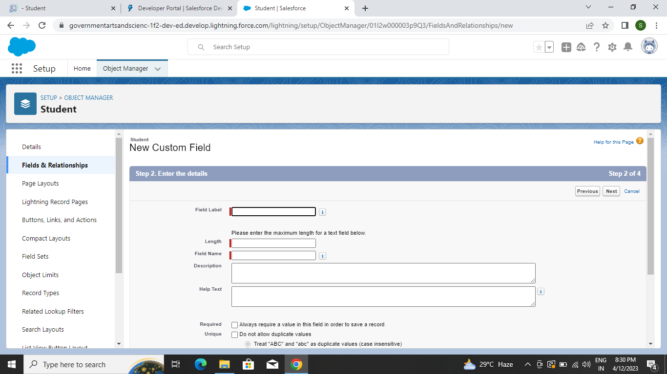

**Milestone -3:**

Fields and Relationship An object relationship in Salesforce is a two-way association between two objects. Relationships are created by creating custom relationship fields on an object. This is done so that when users view records, they can also see and access related data.

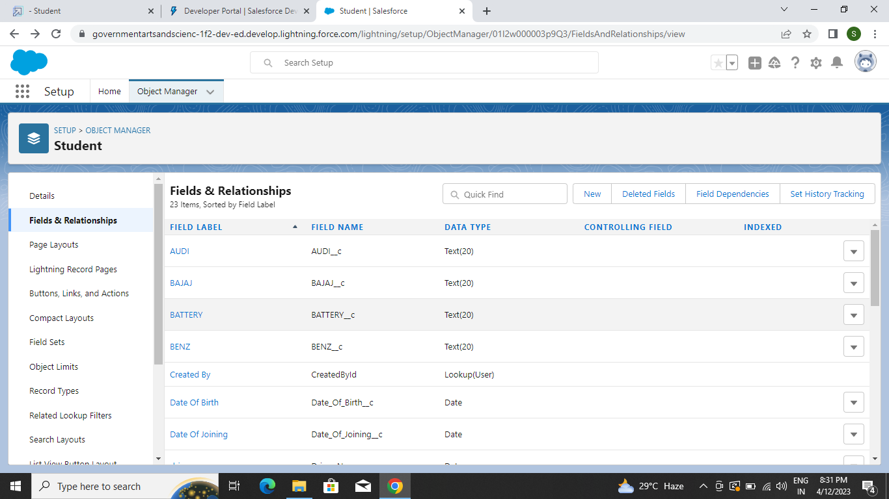

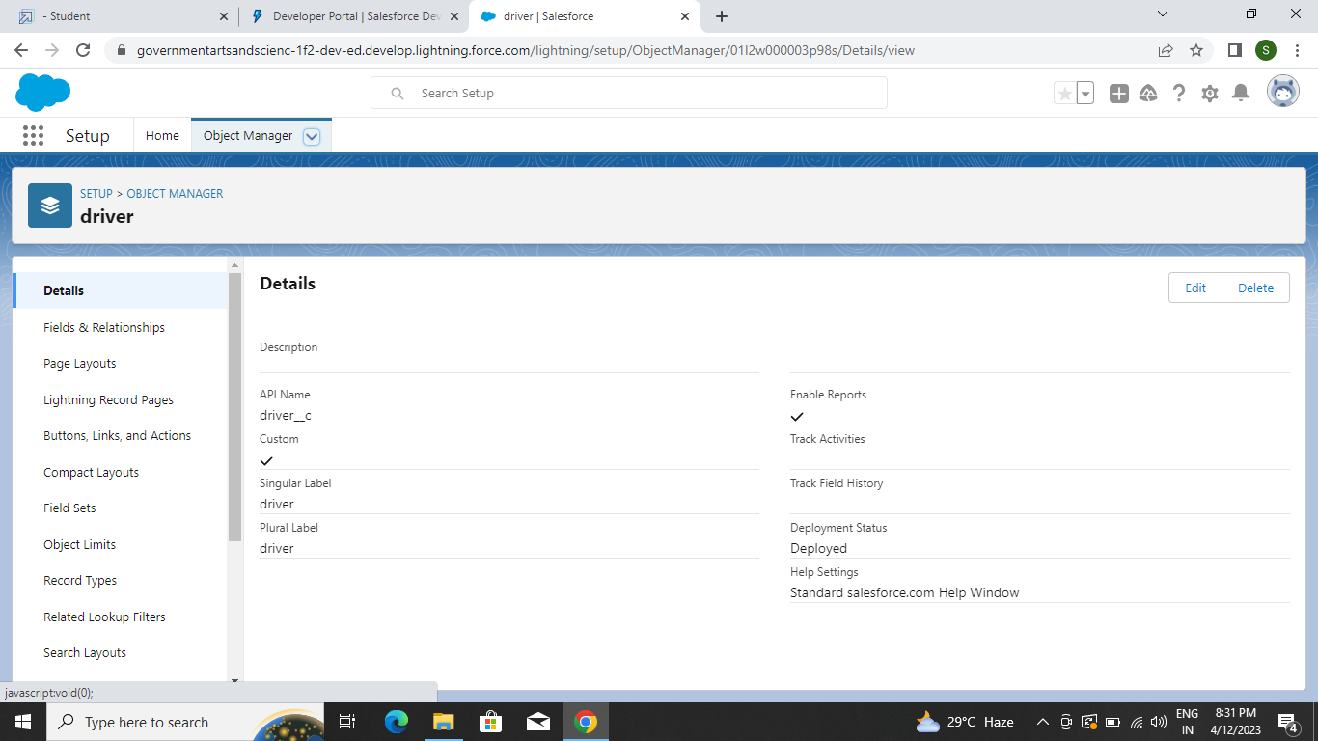

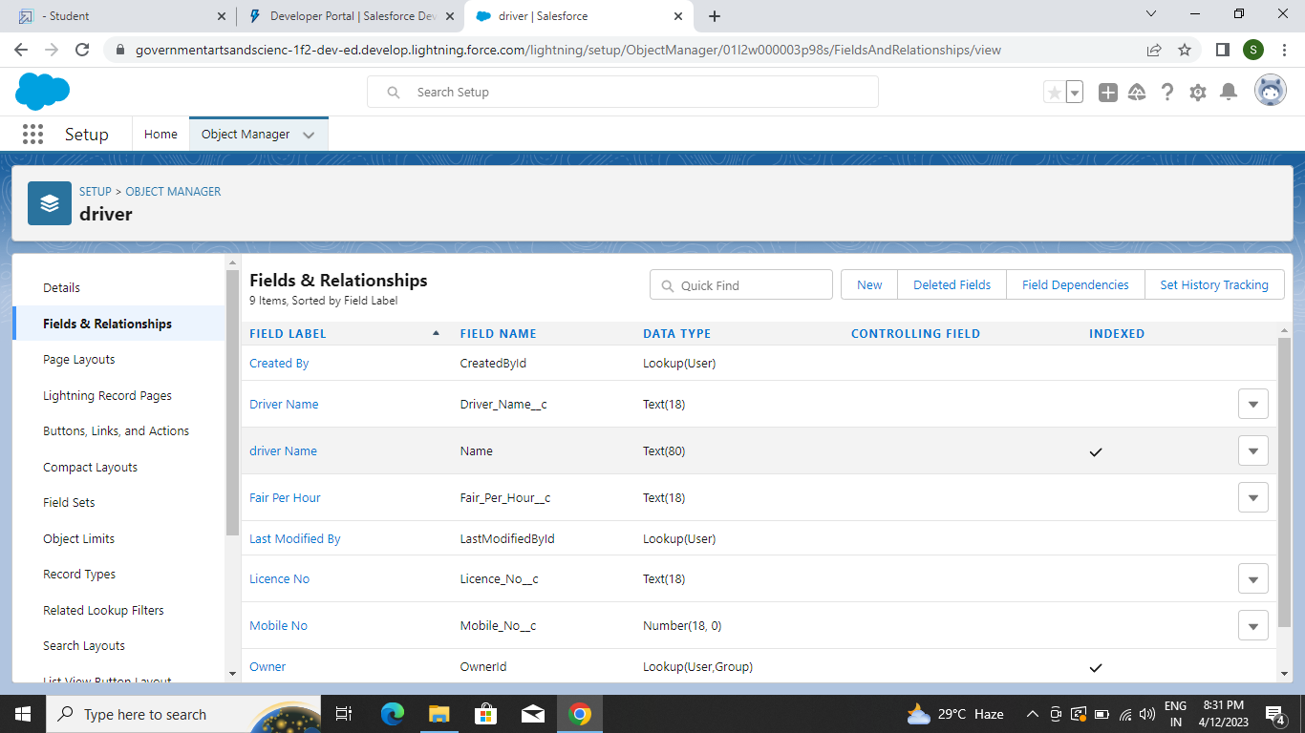

**Milestone-4:**

Lightning App Apps in Salesforce are a group of tabs that help the application function by working together as a unit. It has a name, a logo, and a particular set of tabs. The simplest app usually has just two tabs.

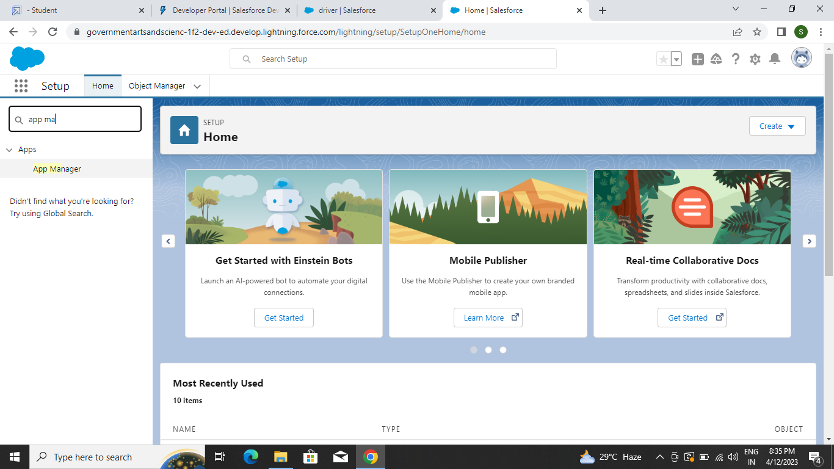

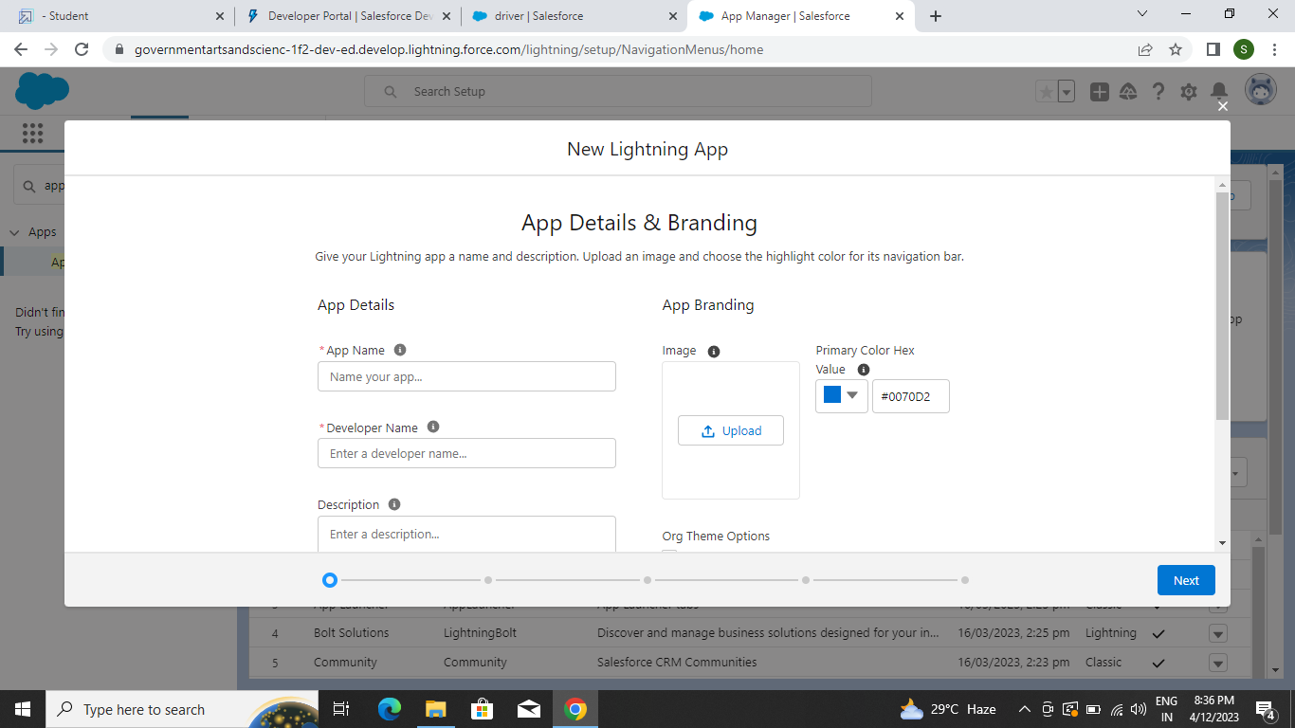

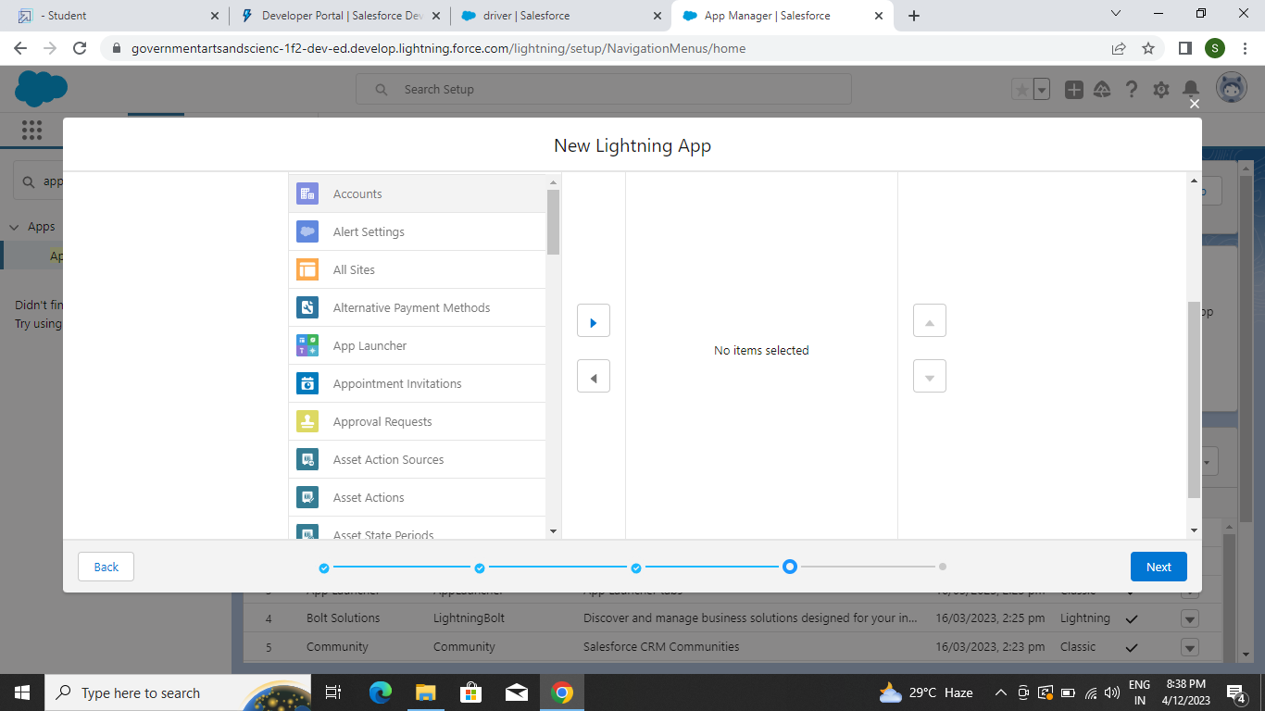

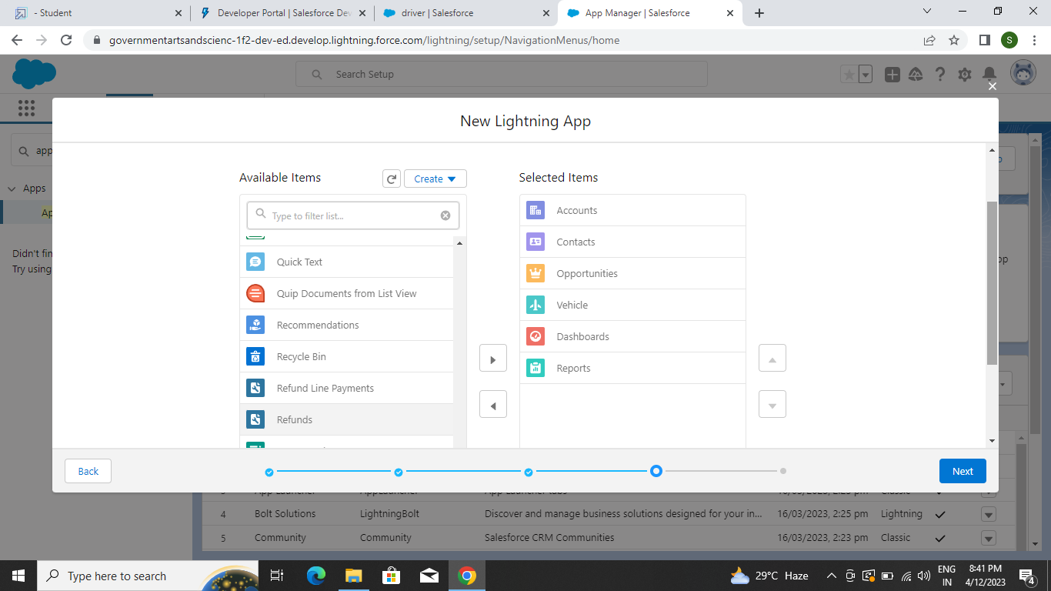

**Milestone-5**: Profile

A profile is a group/collection of settings and permissions that define what a user can do in salesforce. A profile controls “Object permissions, Field permissions, User permissions, Tab settings, App settings, Apex class access, Visualforce page access, Page layouts, Record Types, Login hours & Login IP ranges.

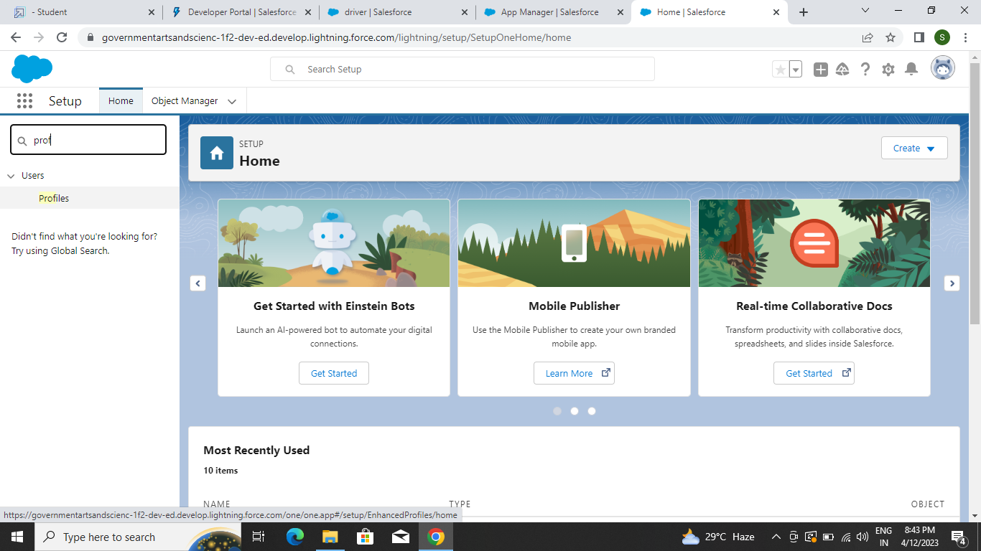

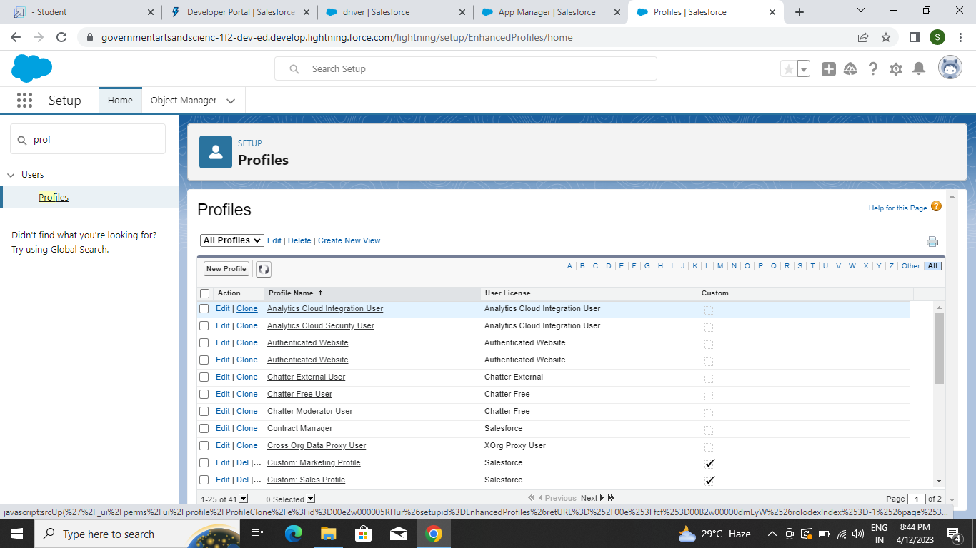

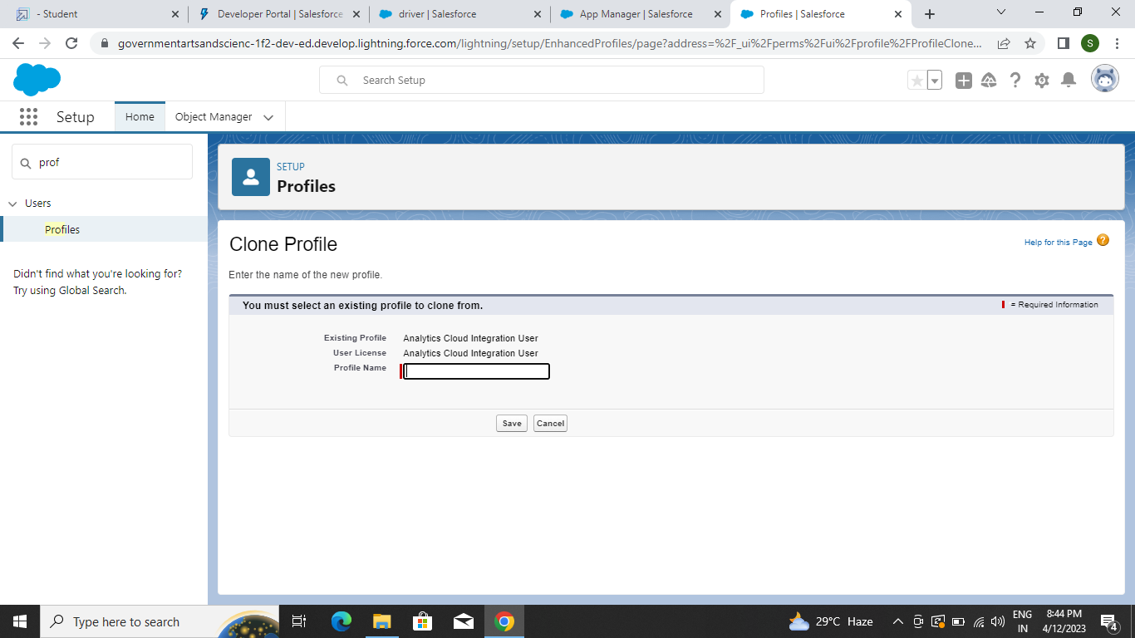

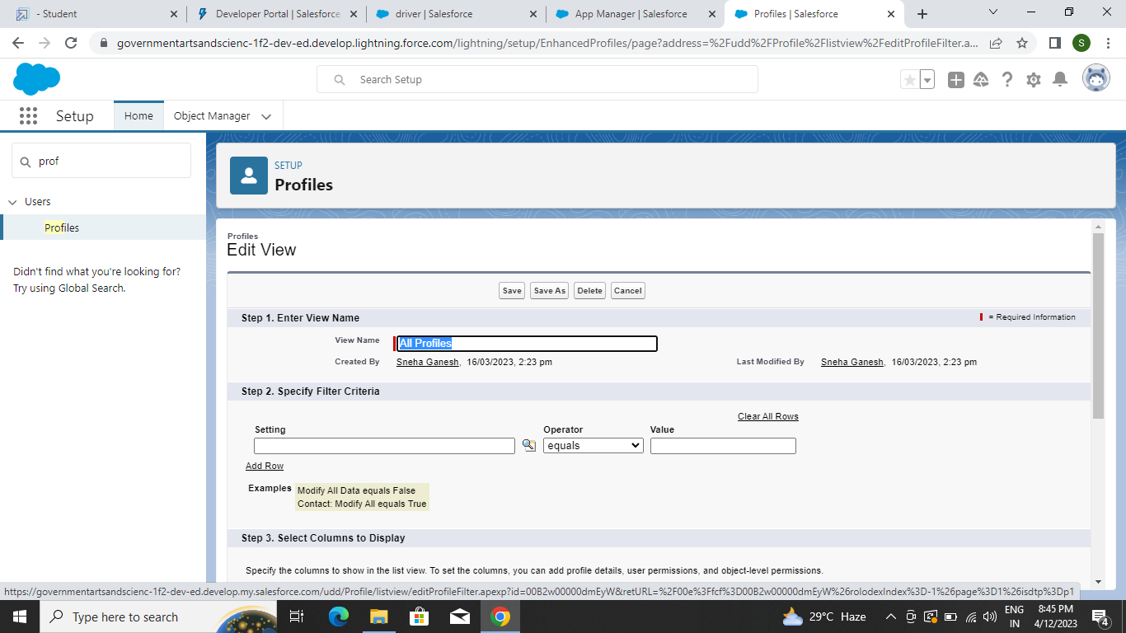

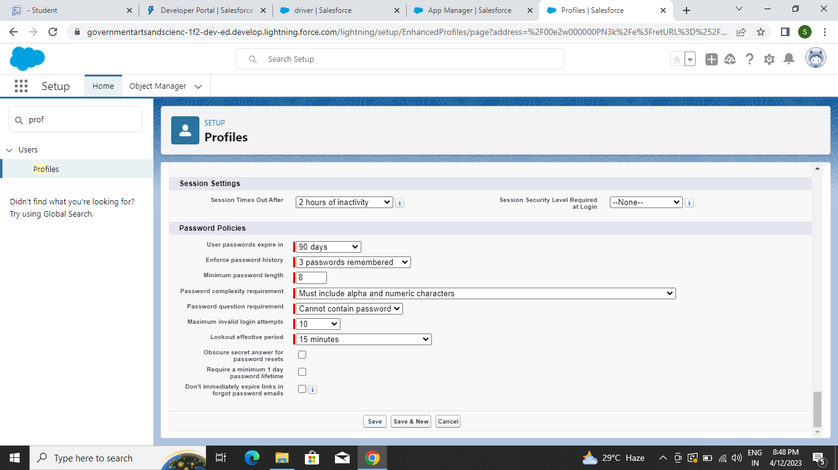

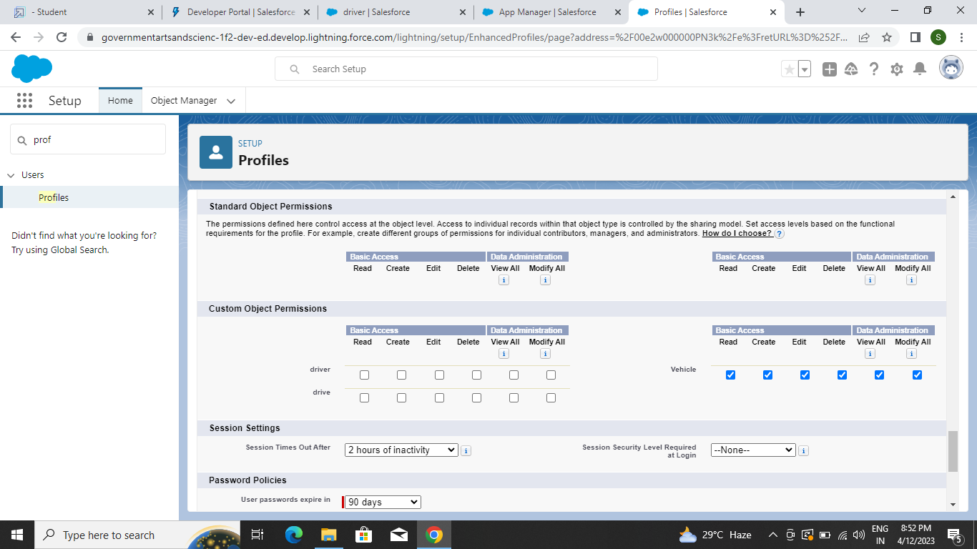

**Milestone-6: Users**

A user is anyone who logs in to Salesforce. Users are employees at your company, such as sales reps, managers, and IT specialists, who need access to the company's records. Every user in Salesforce has a user account.

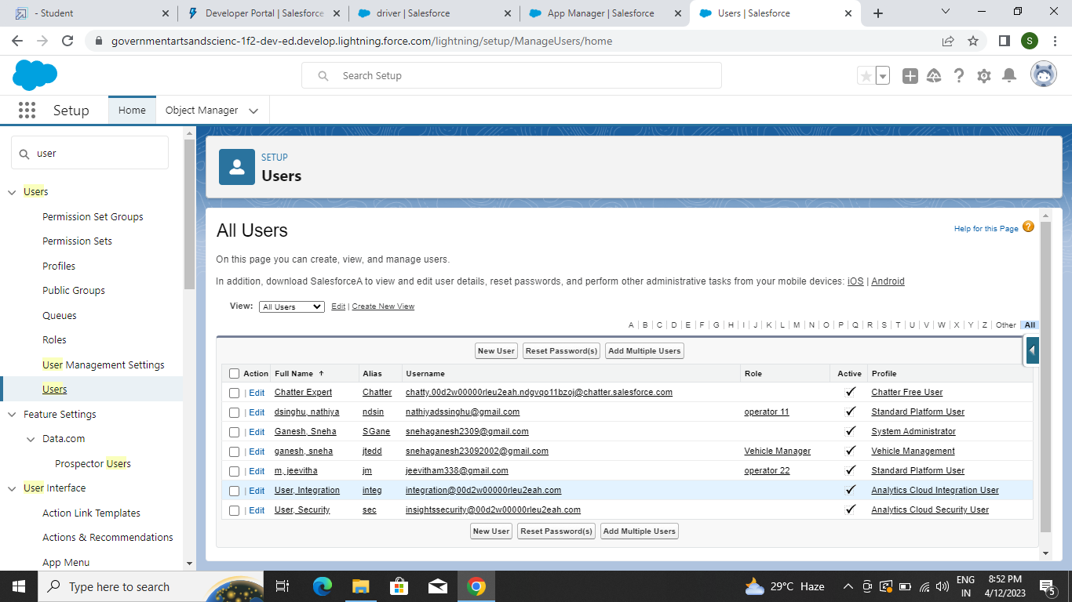

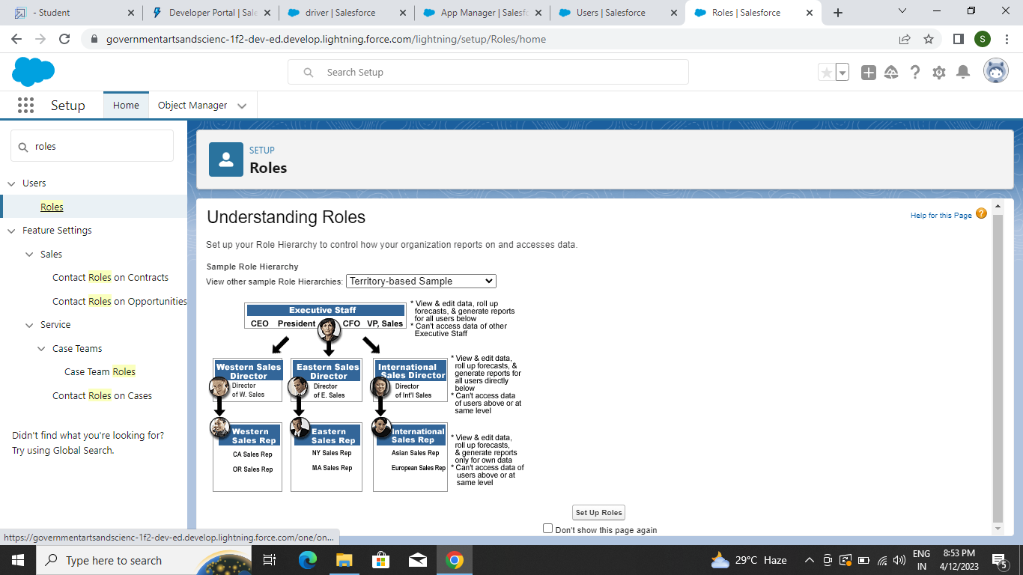

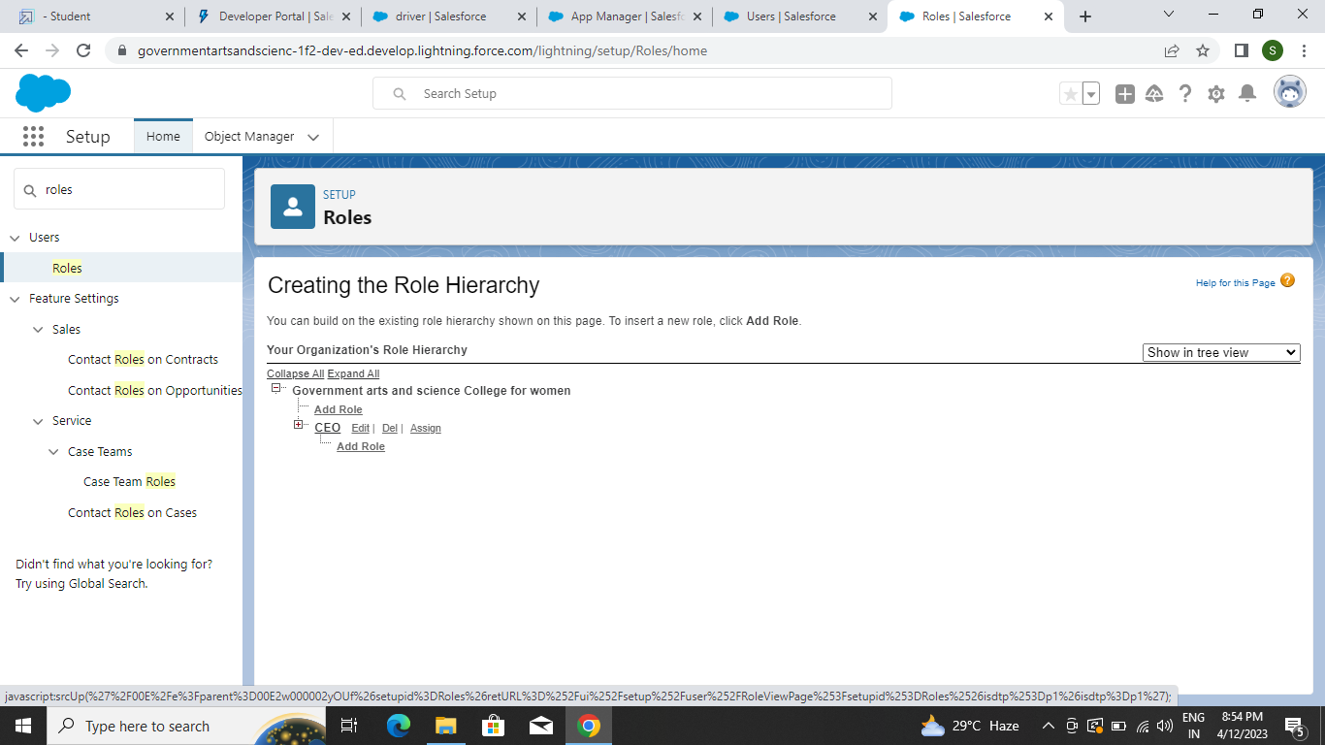

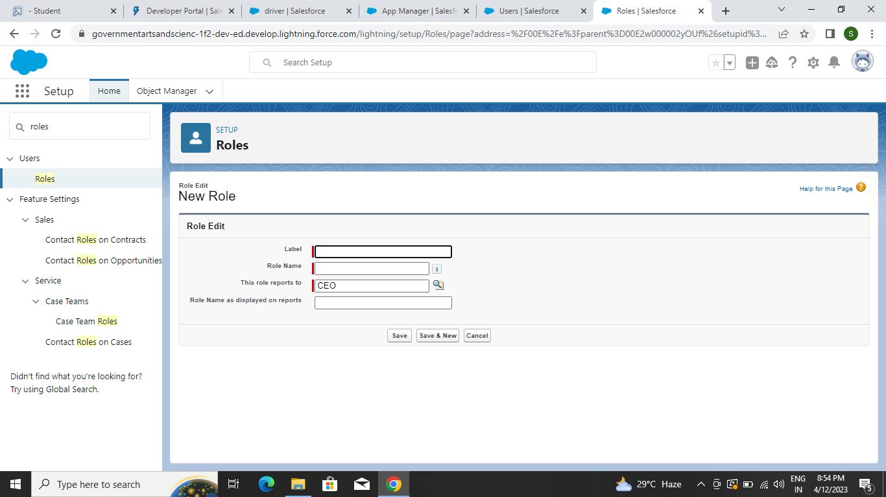

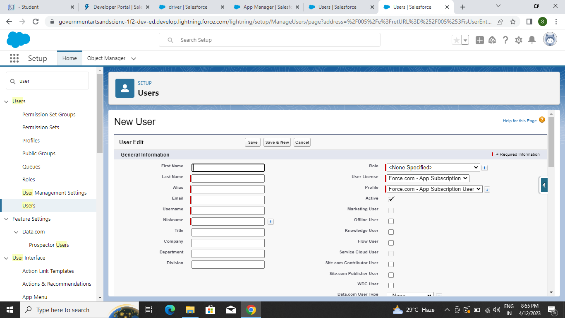

**Milestone-7:Reports**

A report is a list of records that meet the criteria you define. It's displayed in Salesforce in rows and columns, and can be filtered, grouped, or displayed in a graphical chart. Every report is stored in a folder. Folders can be public, hidden, or shared, and can be set to read-only or read/write.

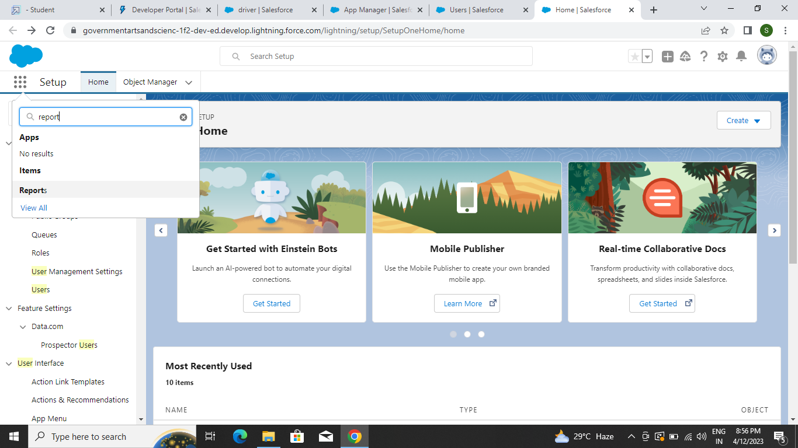

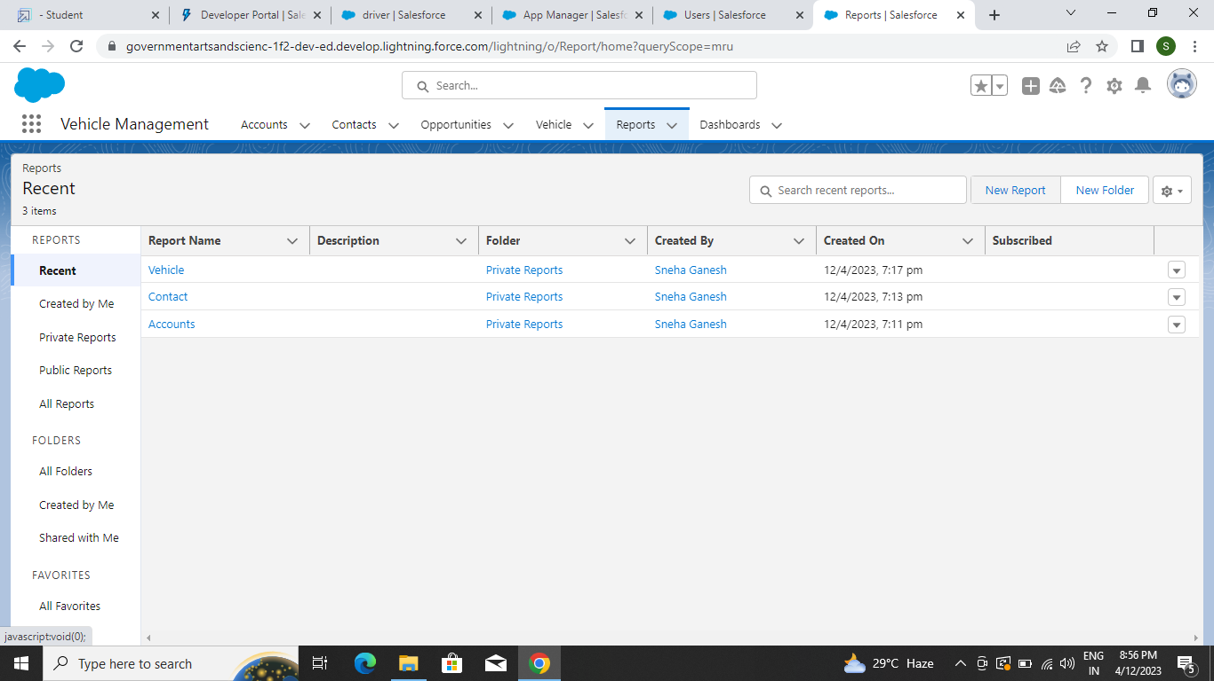

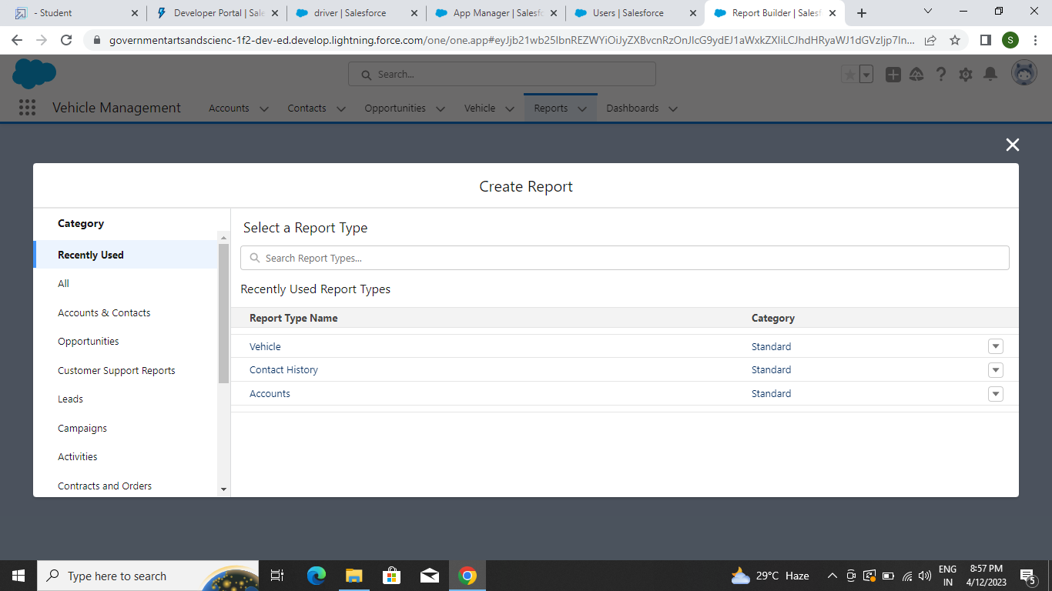

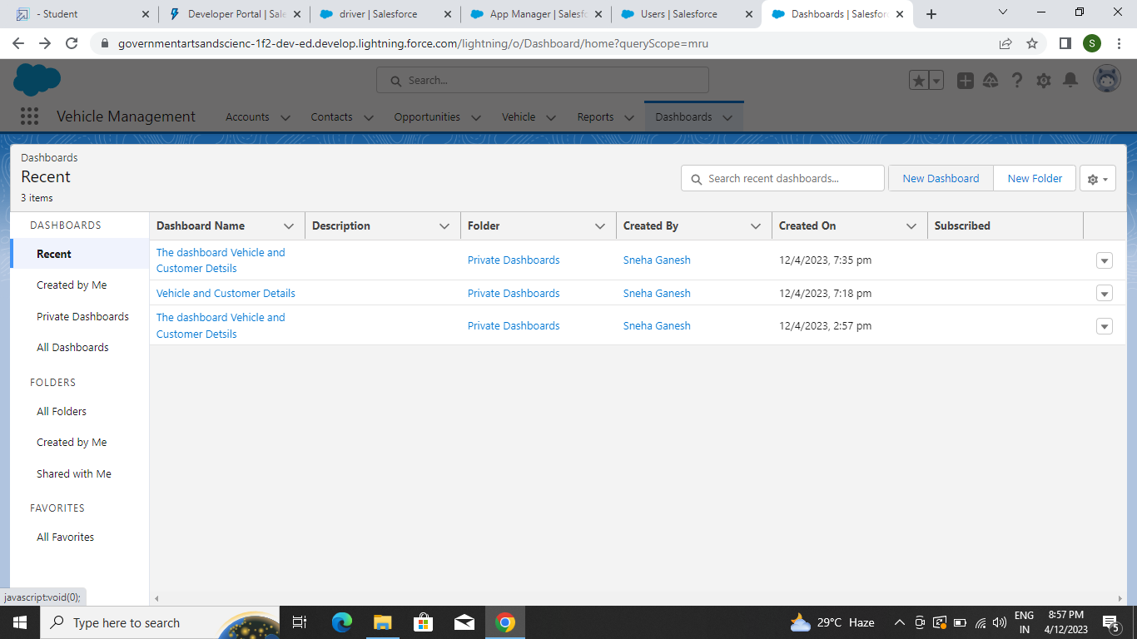

**Dashboard:**

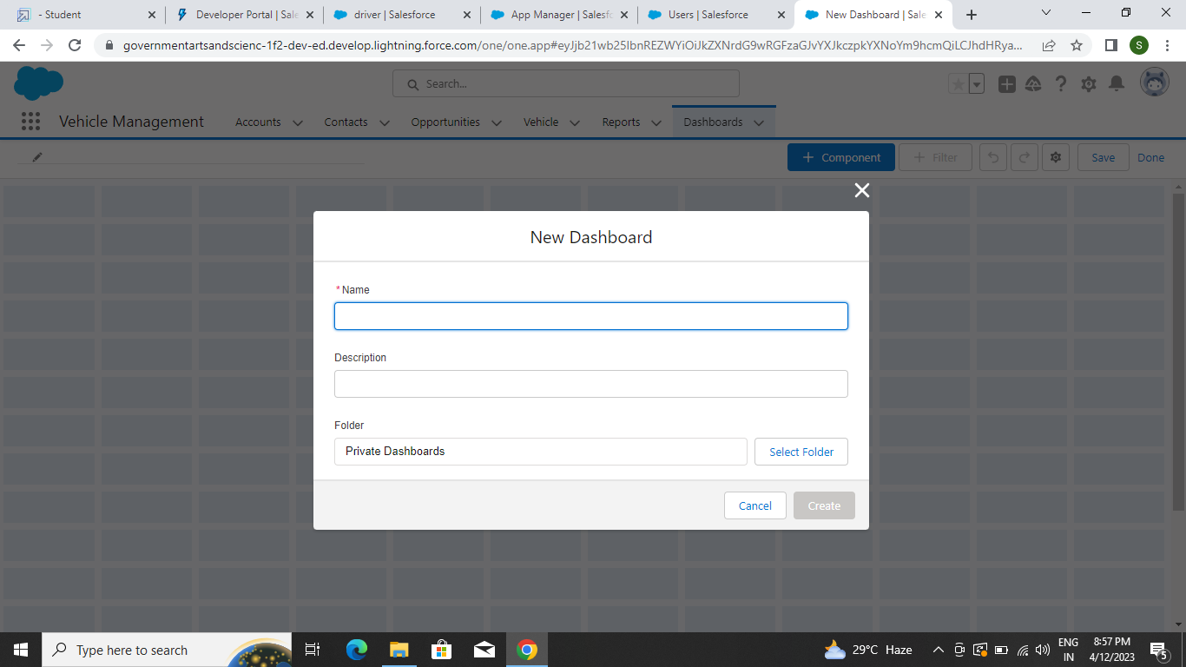

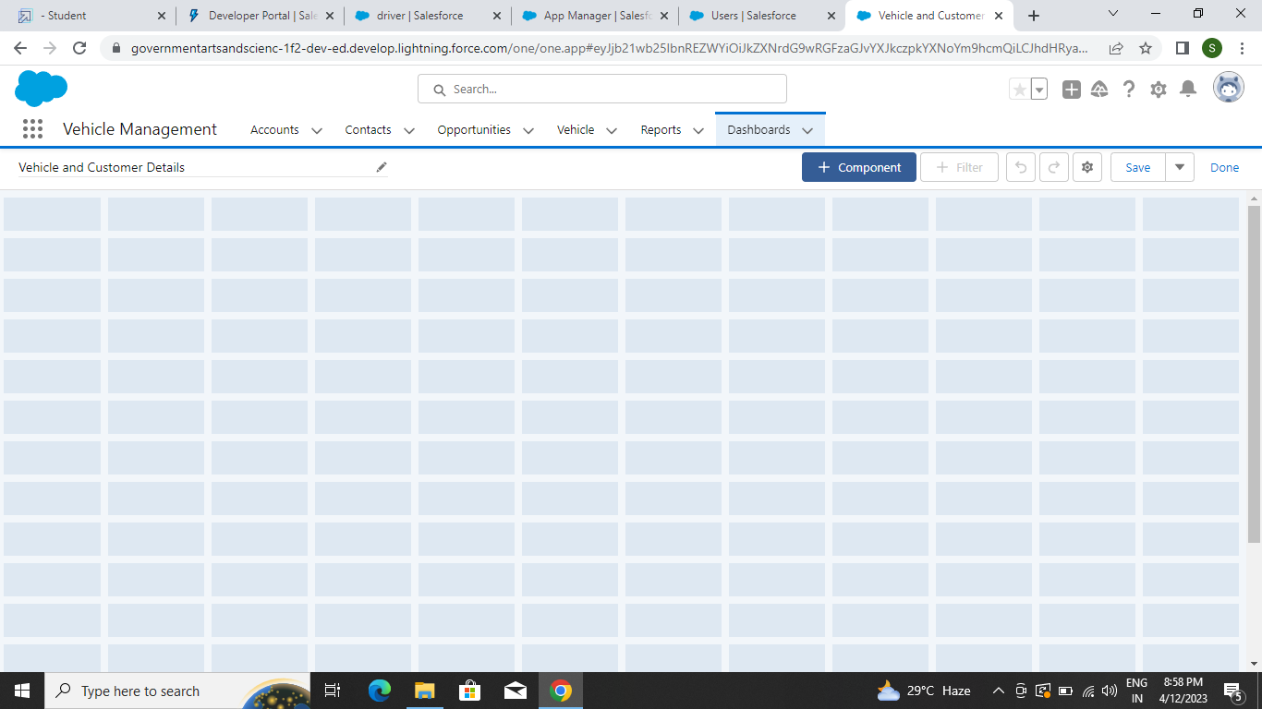

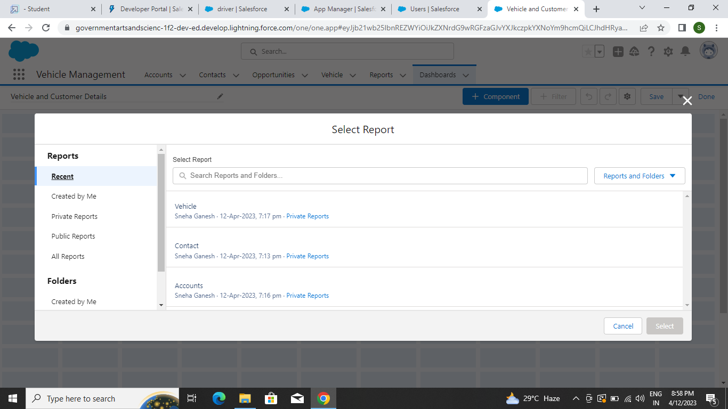

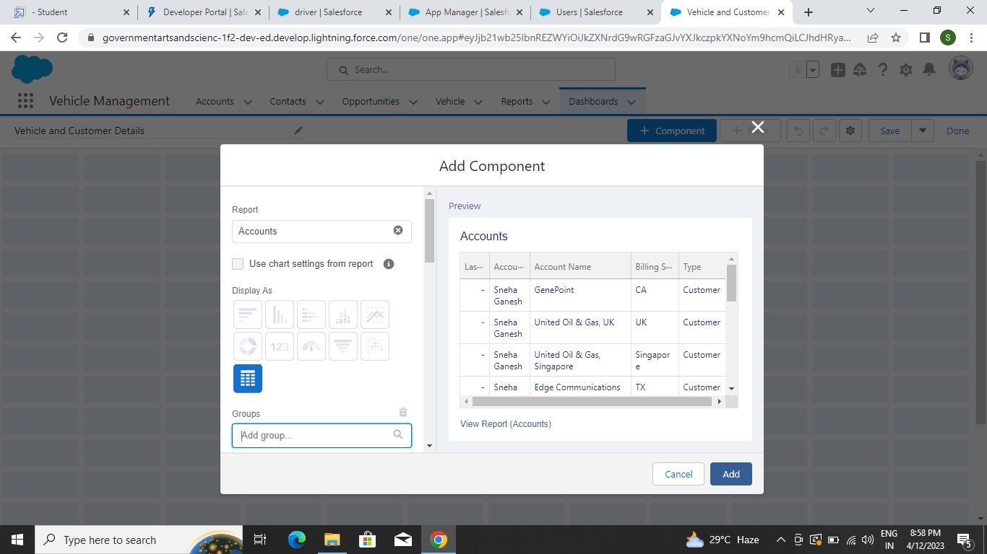

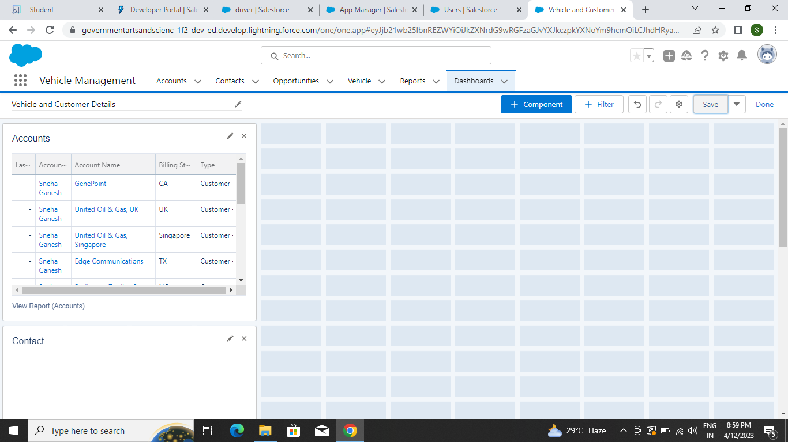

**4.TRAILHEAD PROFILE PUBLIC URL**

Team Lead-<https://trailblazer.me/id/ndesinghu>

Team Member 1-<https://trailblazer.me/id/jeevi14>

Team Member 2-<https://trailblazer.me/id/priyb35>

Team Member 3-<https://trailblazer.me/id/tkodi6>

Team Member 4-<https://trailblazer.me/id/sganesh227>

**5.ADVANTAGES AND DISADVANTAGES**

* **ADVANTAGES**

1. Easy to process requests
2. Can generate required reports easily
3. Easy to manage historical data in a secure manner
4. Centralized database helps in avoiding conflicts.

* **DISADVANTAGES**

1. It is difficult to track the occupancy.
2. More manual hours need to generate required reports
3. It is tedious to track the details of cabs provided by third party
4. Finally so hard to the report milestone.

**6.APPLICATION**

* Improve fleet safety and working condition.
* Schedule shifts and work hours.
* Schedule routine maintenance.
* Leverage driver retention .
* Manage fuel efficiency.

**7.CONCLUSION**

The Corporate Company’s Vehicle Management application has rich user interface so that novice users can access easily. This application provides the management reports like Occupancy report, approval status reports, to track the usages of company ’s transport facility.

Our project is only a humble venture to satisfy the needs in library. Several user friendly coding have also adopted. This package shall prove to be a powerful package in satisfying all the requirements of the organization . The object of software planning is to provide a frame work that enables the manger to make reasonable estimate made with a limited time frame at the beginning of the software project and should be update regularly as the project progresses. Last but not least it is no the work that played the ways to success but ALMIGHTY.

**8.FUTURE SCOPE**

Keep track of the vehicles in real-time, plan, execute.

Optimize their transportation processes through GPS and data collection.